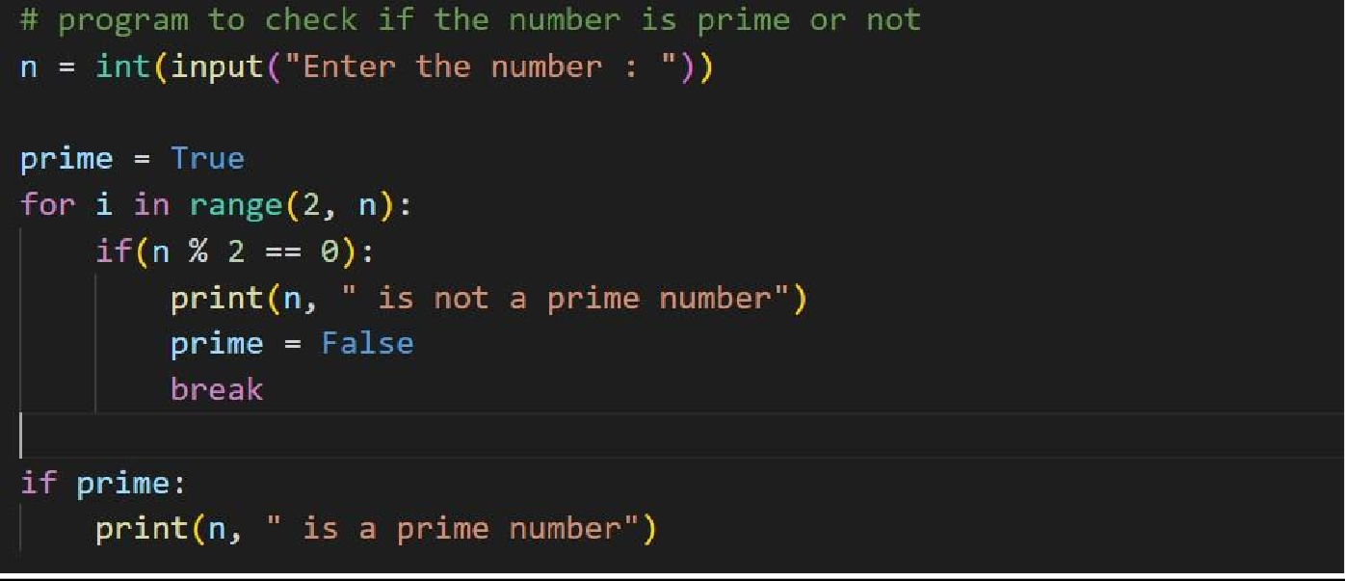Program1:

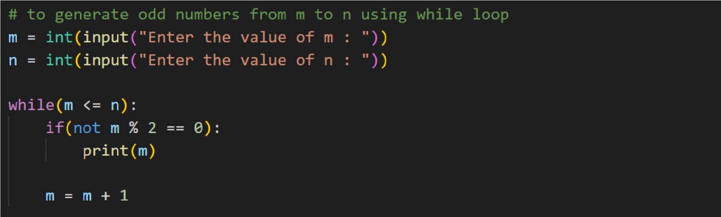Program2:

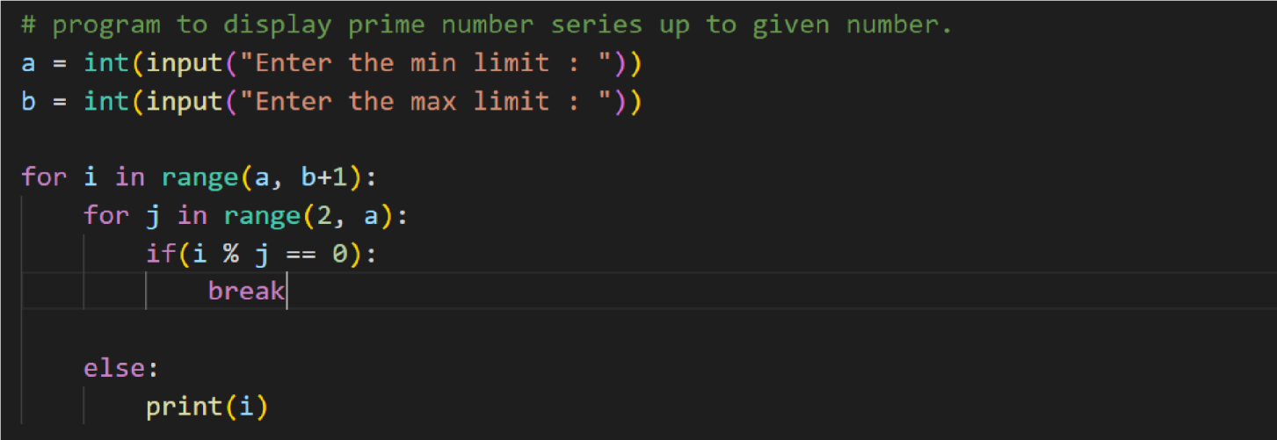Program3:

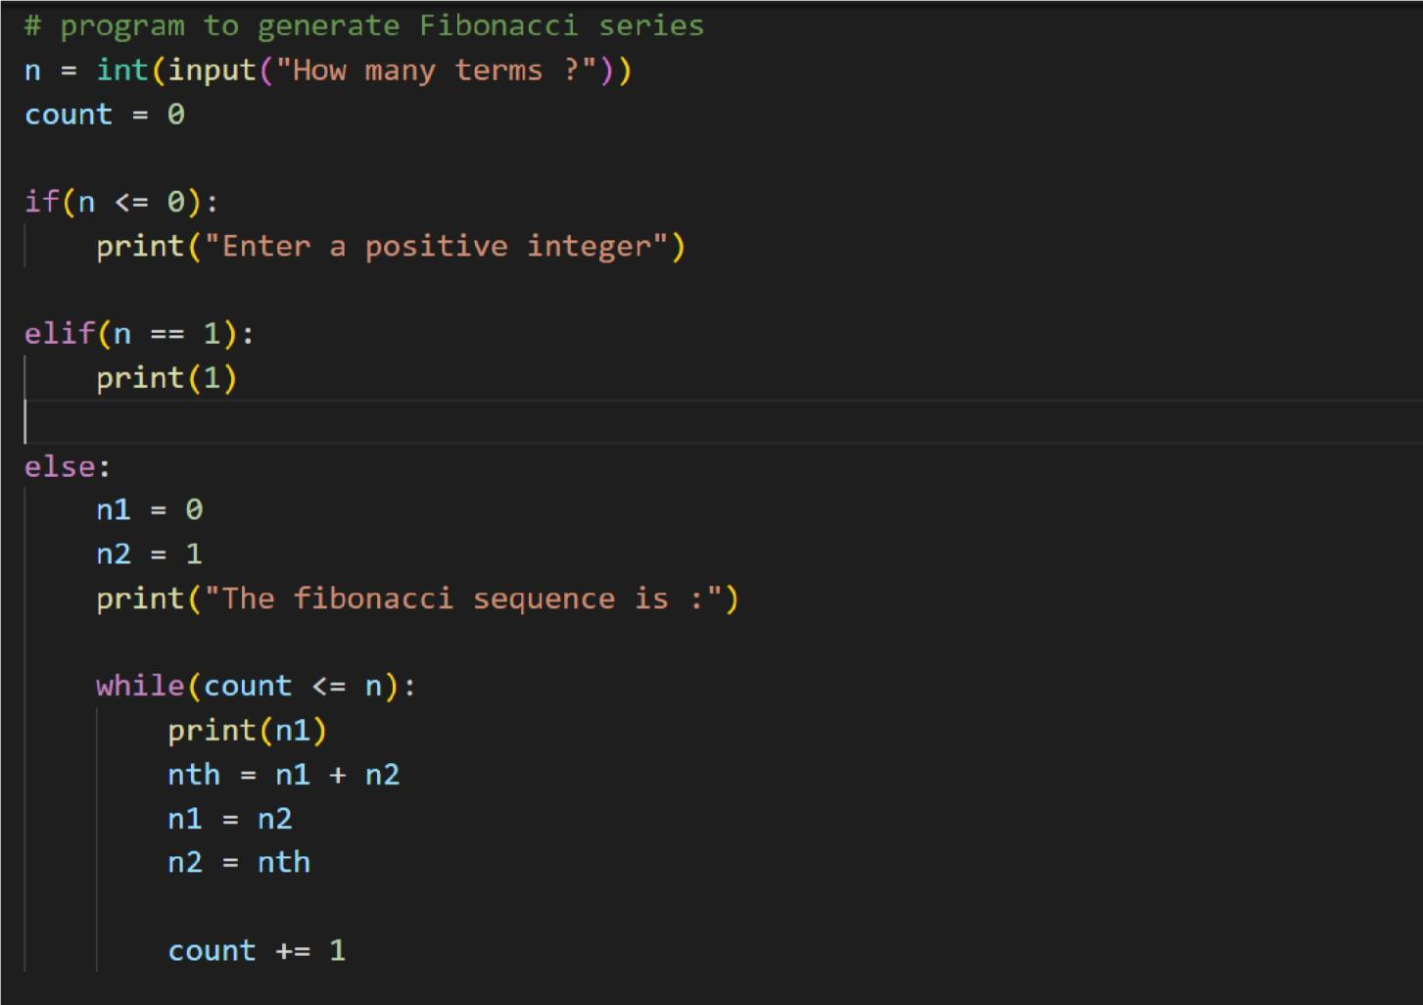Program4:

**Submitted by**

1. Rebisha S
2. Pravin M
3. Sharan B
4. Saju Shagaar M M